Software Requirements Specification
for
<TAIGA INC>
Version 0.0.1 approved
Prepared by <JANAKI RAM>
<SOFTWARE ENGINEERING CS301>
<30-08-2018>
Table of Contents
Table of Contents ii
Revision History ii
1. Introduction 1
1.1 Purpose 1
1.2 Document Conventions 1
1.3 Intended Audience and Reading Suggestions 1
1.4 Product Scope 1
1.5 References 1
2. Overall Description 2
2.1 Product Perspective 2
2.2 Product Functions 2
2.3 User Classes and Characteristics 2
2.4 Operating Environment 2
2.5 Design and Implementation Constraints 2
2.6 User Documentation 2
2.7 Assumptions and Dependencies 3
3. External Interface Requirements 3
3.1 User Interfaces 3
3.2 Hardware Interfaces 3
3.3 Software Interfaces 3
3.4 Communications Interfaces 3
4. System Features 3
4.1 System Feature 1 4
4.2 System Feature 2 (and so on) 10
5. Other Nonfunctional Requirements 12
5.1 Performance Requirements 12
5.2 Safety Requirements 12
5.3 Security Requirements 12
5.4 Software Quality Attributes 13
5.5 Business Rules 13
6. Other Requirements 13
Appendix A: Glossary 13
Appendix B: Analysis Models 13
Appendix C: To Be Determined List 14

Revision History
Name | Date | Reason For Changes | Version
Janaki Ram |  | Included idea of speech to text Recognition | Version 0.1.1
Janaki Ram |  | Changes in Use case diagram | Version 0.1

Introduction

Purpose
Purpose of TAIGA INC is to make sure that people can teach and learn the area they are interested in and also the main motive of our project is that if someone enters our website with a doubt on a particular topic we want that doubt to be solved in our website without providing different links and confusing people. We are also allowing people to sell their products online which might be digital or physical and we are going to sell our own cool merchandise as well.

Document Conventions
First priority in our project is going to be the teaching and learning platform(text and videos) for different streams and our second priority in this web app is going to be the feature of allowing people to sell their valuable products online which may be a digital course or a physical book or anything related to the stream written by them. Next important feature in our web app is our E-COMMERCE store which consists of some cool merchandise and education related products.

Intended Audience and Reading Suggestions
The intended audience for this audience are going to be-:

1.People who are interested in selling and teaching online.

2.students who are interested in learning online.

3.web developers and affiliate marketers can understand our product and think to add more about it.

Product Scope
Our product is going to help all the students and teachers around the globe. Every person who wants to teach or learn something can use our products as it is going to have better features than all the existing platforms in the mark etc. People can also sell their products online and can take help of affiliate marketers to promote their product so our website is basically going to help people learn as well as earn money by teaching,selling and promoting their favorite products online. Our revenue model is basically from our subscription services to students as well as ads that are going to be published on our site.

References**
This is completely our own idea.
Reference for the technologies that are being used is mostly taken from youtube.

Overall Description

Product Perspective
Our Product TAIGA INC is a follow on member of online education platforms but with a unique goal to have the best user interface and services possible.

Product Functions
TAIGA INC is going to have wide range of functions -:
1)our product allows users to post questions and answer for any question in the streams that they choose
2)people who are enthusiastic to teach their passion or interest can start their tutorials online and we will be charging the students based on the subscription policy.
3)we have a wide range of merchandise for people to buy in our site.
4)people who create a book or a digital course or an art or anything valuable can sell their items on our site with approval.
5)Affiliate marketers can make complete use of our site by promoting the products that they like from our site and promoting them and can earn commission.

User Classes and Characteristics
Users are general people around the world. considering user to be a class he can register and login ask questions and can also post videos and teach and sell anything.
Unregistered user- they don’t have access to anything but only to our home page.

Operating Environment
Our website can be accessed on any browser, operating system. The website is going to be responsive enough to be used on mobile browser.
Technologies being used for our project are-:
1.HTML
2.css
3.bootstrap
4.php
5.Mysql()

Design and Implementation Constraints
The data storing capacity for us right now is limited to us. our users are not going to have any limitations as the web app we are designing is for the people to the people but its by us for them.

User Documentation
User will have to accept the private policy and highlighters will help them to understand different options that are available for them and guide them throughout the whole website.

Assumptions and Dependencies
Our assumptions and Dependencies in technical terms are security and safety of our users as well as bringing audience or users who can teach on our site and make a living. Marketing is our main goal now in order to attract people to our website and consume what we are giving them in an effective way. The payment gateway is the part where we need to get lot of permissions and make sure that all the transactions taking place are secure.

External Interface Requirements

User Interfaces
Our web app is going to have a UI which is captivating and simple for which we are going to create some designs and animate them and we are going to style our web app using CSS and we will have different buttons and pages for different sections of our website.

Hardware Interfaces
Our web app needs only internet connection and a web browser to work on any system.

Software Interfaces
The basic things are HTML and CSS which are used for the front end of the we app which user can see and for server response and storing users data initially we are going to use PHP and Mysql and as our customer network increases we would require a database and we are going to make our payment processing and all using java script which helps in security purposes as well as approval for users to access and check whether their credentials are correct or not. In order to make our website more interactive we are going to use Bootstrap.

Communications Interfaces
HTTP is our website standard communication protocol as our web app is going to be a public platform, there would be no encryption in our website front end but there might be back end encryption used for payments and some other activities in order to keep our site safe and secure
Every question people want to ask another person can ask by mentioning him or her. so no encryption needed for text here.

System Features
<This template illustrates organizing the functional requirements for the product by system features, the major services provided by the product. You may prefer to organize this section by use case, mode of operation, user class, object class, functional hierarchy, or combinations of these, whatever makes the most logical sense for your product.>

System Feature 1

4.1.1 Description and Priority
Our first priority is to allow people to learn and earn as well. One of the main features in our project is going to be voice to text conversion for children who cant type.
4.1.2 Stimulus/Response Sequences
For all the users there will be a registration page and thereafter they have to login to their own account and can select their stream of interest and start posing questions or can directly upload something to sell or teach. users who are teaching or selling products will have responses based on their followers and likes on the particular thing that they upload
4.1.3 Functional Requirements
REQ-1:
Our database requires a good database in order to store the data of users.
REQ-2:
2)The website needs to be very responsive for which we are using bootstrap.
REQ-3:
3)the users data needs to be secure for which we will be coding in the most secure way possible.

4.1.4 Customer section

our customers are our users so the first task that they have is to login to their account or register with us.

LOGIN -

CASE 1)The user have to provide with the correct credentials or if they are new users they have to register and login.

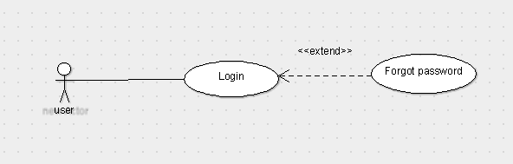

ALTERNATE CASE -

If the user forgets hid or her username or password then they will be provided with an option which is forgot password?? and further credentials would be communicated through Email,

The authentication that needs to be done in order to reset the password of the user is represented as following

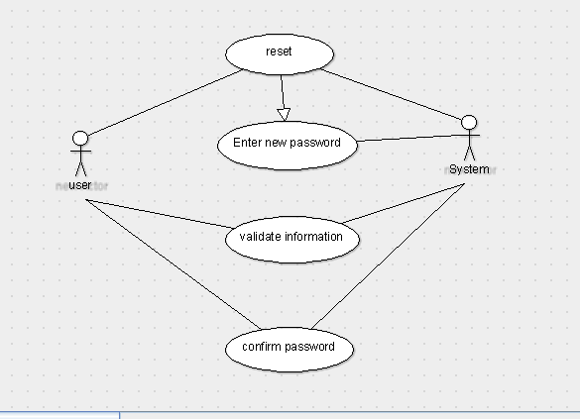

HOME PAGE -

After logging in the users will be taken into a home page where they will be shown with different options.

The options which would be available on the home page would be -

1)preferences or categeories

2)Ask/Add a question.

3)Answer a questions

4)Become a trainer
5)Google speech to text converting assistant

6)E-commerce.

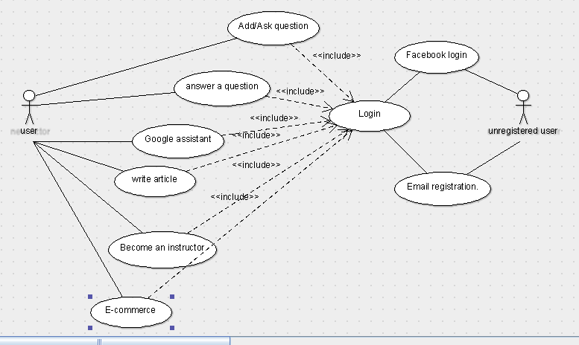

Immediately after logging into the site we get to see a home page with all these options and by default it will be showing us our favorite stream.

The users can view the questions posted and can answer any question that they want.Users can also use google assistant to browse through our website.

Users who are good at something can start their channel officially and get popular.

Use case for asking and adding a question -

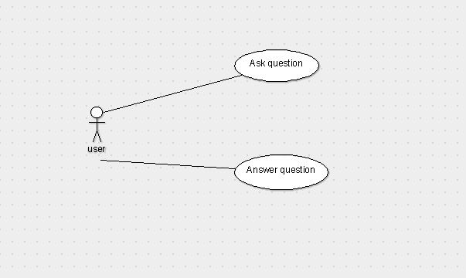

BECOME AN INSTRUCTOR -

Once the user presses this option he will have a chance to create his own blog or channel where he can give tutorials about his passion or can teach something that’s really helpful for the people.
Instructors or trainers have an option to upload videos and create their own page within the website where he can post his answers and post videos or reply videos or anything it can be.

These people can also sell their digital products nline and make some money.

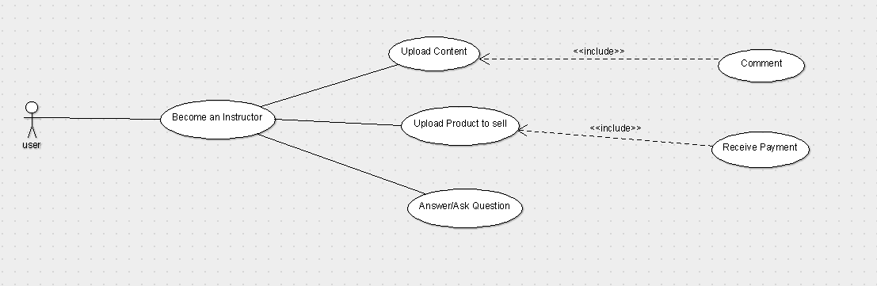

E-commerce-

1)Users can buy/sell products.

Use case for buying and selling

Buying-

Selling -

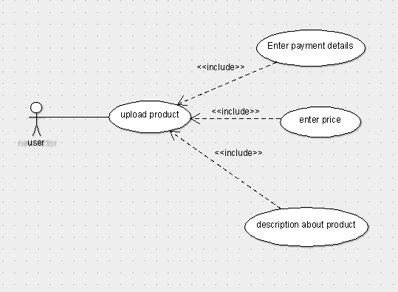

Preferences-
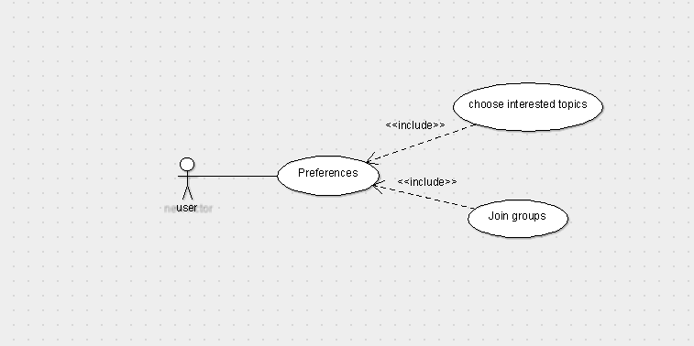

Every user gets an option to choose their interests in the beginning of signing up process but they can change their preferences or can also increase their number of preferences.

Users can post their questions and questions and get replied for their questions and they can view videos like and comment them and also they can give ratings for the products that people sell on our website

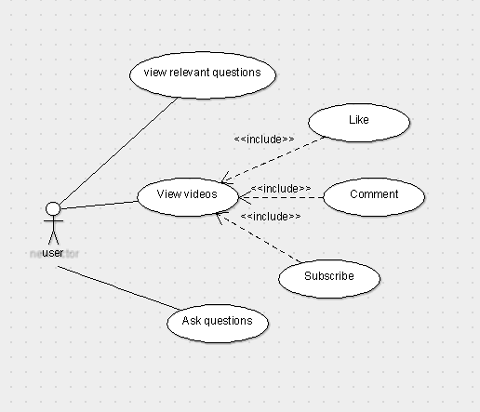

4.2.1 UI classes and use cases

The users can view the

questions posted and can answer any question that they want.Users can also use google assistant to browse through our website.

Users who are good at something can start their channel officially and get popular.

Use case for asking and adding a question -

Users Dashboard-:

The first page that users see is their dashboard after registering with us.

The first stage is registration where user have to create an account with his Email ID and password which will be stored in database.

The user have to login to his account where for authentication we prove username and password sections.

Case-1-: If the user enters correct username and password then he will be taken to the homepage.

Case-2-:if the user enter any wrong credentials a message will be shown.

Case-3-:if the user forgets his password we provide him with an option where user can change his password through OTP system.

Once the users enter to their home page they will be asked for their preferences for a course they can choose any of them. and they will find the present conversations and can add a question and a comment and also watch videos. And they will also have an option to become an instructor and most important is people who are from arts fields and people who might be good in some subject might have written a book but have issues with publishers these kind of people can access our site to sell their products or at least show the world what they have done.

From a drop down menu from the navigation bar users can see options(or)services like
1)Become an instructor
2)Sell
3)Buy
4)preferences(people might be interested in new choices everyday).
5)Notification
6)your courses.

Below the navigation bar in the content division people will be joined into different pages for different interests for example space enthusiasts will have a forum and so different forums for different interests.

People can get answers from some of the most popular teachers which might have a big difference on you.

Become an instructor-: This feature is for the People who want to teach their skill to someone so they will have an access to upload a video and to have his own channel and can create a business out of it.

Buy-: People can go to this e commerce page to find the products that people want to send it might be a digital book or an art piece or anything that people want to sell out of their creativity and skill.

Sell-:Sell option will be exclusively available for everyone but people who are not instructors have to pay subscription services for selling their products.

Your courses will contain the courses that you have chosen.

The company handles the data and logs of the users and also updates the web site on time to time basis.

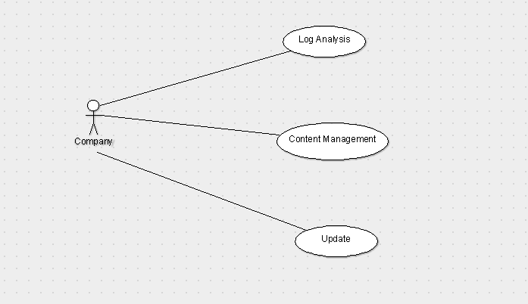

Other Nonfunctional Requirements

Performance Requirements
Performance requirements for our project are good browser,internet connection ,good domain to deploy our website and a proper functional google API for our voice assistant.

Safety Requirements
We need to be careful while designing our website as there is a change for the hackers to tamper with our website and privacy of our users data is very important. In order to keep their information safe we need to follow encryption techniques for storing the data which would be done if traffic on our site increases.

Security Requirements
1)Users must login to their account to use our site completely so users authentication is very helpful to keep their own accounts secure and safe.
2)Users will have to use safe payment portals in order to complete their transaction successfully
and accurately.
3)All the shared data by users based on the subjects or skills are open to anyone and this data do not face any security problem as it is related to education until our whole website gets hacked.

Software Quality Attributes
Our software is going to have a new feature which is going to allow any person of any age to ask a question to clarify his doubt .A 5 year old who cant type can pose a question on our website using the speech to text converter or a layman who cannot write can also take advantage of this.our website is responsive,robust and helps people to learn and create wealth and share the beauty of quality education.

Business Rules
We are designing a website for curious people who want to learn something new each and every day. They are lot of skills to learn in a meaningful way. They are lot of people around the globe who want to learn something new but that something new might be a good skill for some other person who want to earn money through it so our platform is basically solving the problems of people who want to learn and also for people who want to earn.

Our policy in E-commerce is that users cannot sell the used items.

They have to sell their own products and we intend to add verification for their products.

Other Requirements
We might require google APIs for speech to text conversion for now.
Appendix A: Glossary
API – Application program interface.

Appendix B: Analysis Models
